# Convert Jar file to OSGi Bundle

<https://www.youtube.com/watch?v=4r5tW6b2u2I>

**What differentiates an OSGI bundle from a normal jar file?**

Headers that are present in OSGI bundle manifest file.

Like, bundle symbolic name, bundle version, etc..

These headers are read by OSGI container and that is how a bundle is deployed on the OSGI container itself.

**How to create an OSGI bundle from Jar file?**

We can use command line to create an OSGI bundle (Should have a JAR file and manifest header file to do this).

Manifest file looks like the one that is shown below.

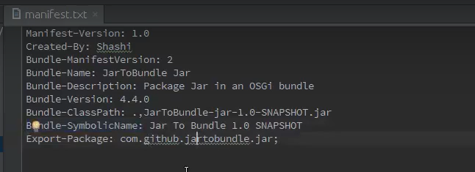

Without a Bundle-Symbolic Name, a jar is not considered as an OSGI bundle. This is the mandatory header we should have.

This jar will not be recognized by OSGI container as an OSGI bundle, if this Bundle-SymbolicName header is not present.